**Dominic Townsend**

**Brief 2 – Speedometer**

**Documentation**

**Overview:**

This project calculates the speed of a moving object that can be controlled by the player (in 8 directions). This value is then translated to a speedometer that appears as a user interface during play. The speedometer consists of a background, an overlay of evenly spaced numbers and a needle that can rotate within a certain angle range. The player/moving object is represented using a green triangle, and has a maximum speed of 60mph (after conversion). The scene also contains a large, tileable background that makes the player’s movements clear.

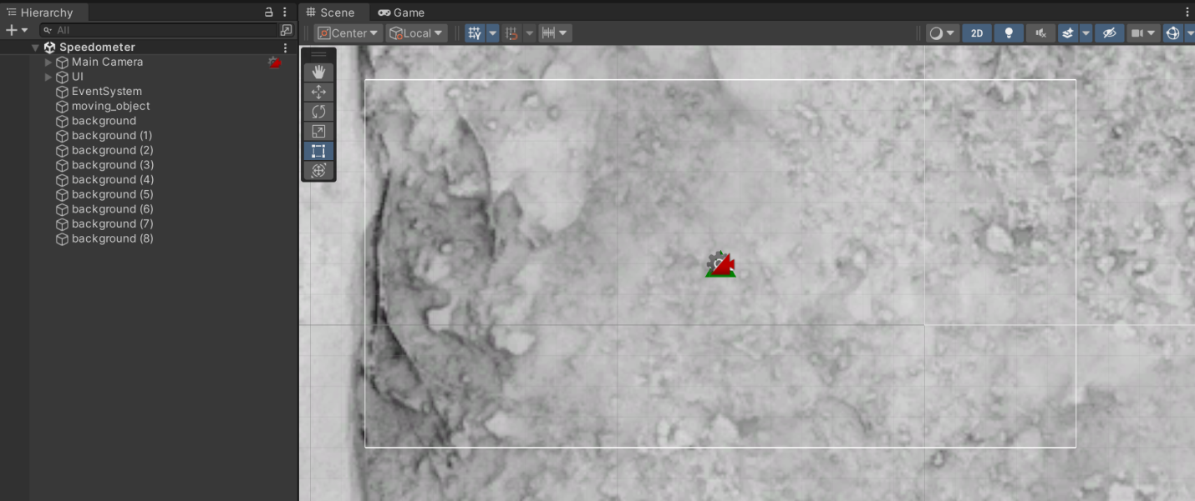

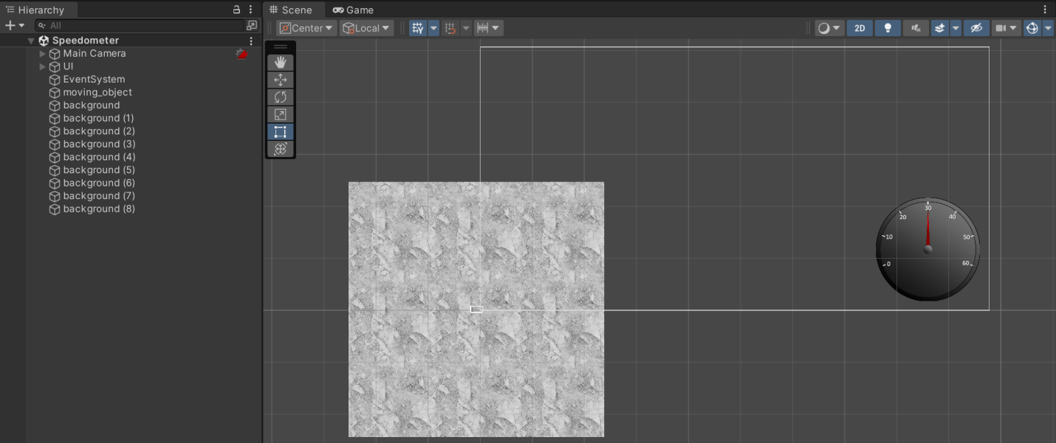

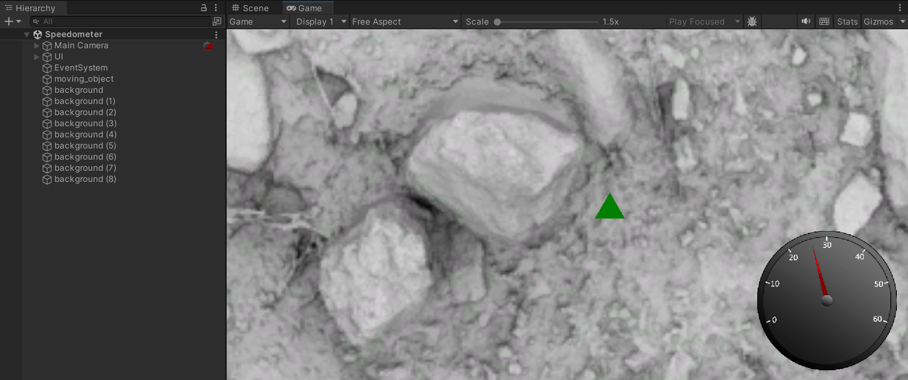

**Assets:**

**Speedometer Assets:**

* speedo_background.png
* speedo_needle.png
* speedo_numbers.png

**Character Assets:**

* moving_object.png

**Other Assets:**

* background.jpeg

**Scripts:**

**Script 1 – needleMovement.cs:**

This script manages the speedometer itself. It sets the minimum and maximum angle the needle can move to, and calculates the velocity of the player. This is then converted from metres per second to miles per hour (by multiplying by 2.23694), and used to rotate the needle to the correct position on the speedometer.

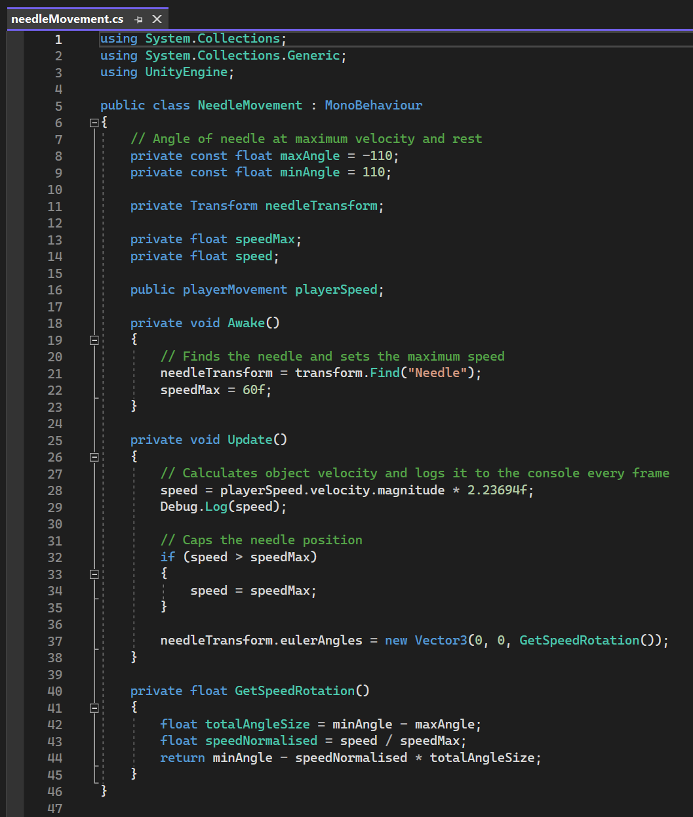

**Script 2 – playerMovement.cs:**

This script allows the user to control the moving object with the WASD keys. In order to make the speedometer more accurate, this movement script also adds acceleration and deceleration, and caps the speed at 26.82236 m/s (or 60mph).

